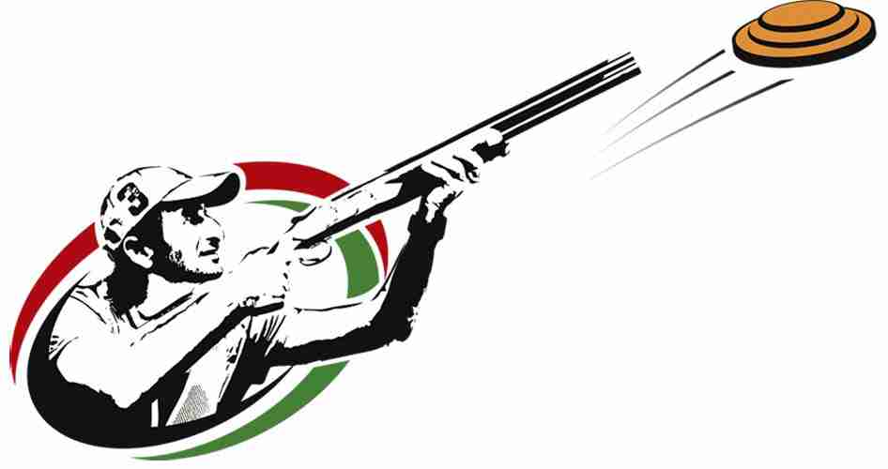
Trap Schedule for 2020
February 22
February 29
March 7
April 4
April 11
April 18
April 25

All Practices will begin at 2 pm
$25 due by March 7

Regional Competition
May 1 for Jr. High
May 2 for Sr. High

